**Name: Vijay Kota**

**Roll no: 150096724074**

**Cohort: mark Zuckerburg**

**Q1. x^3+y^=10**

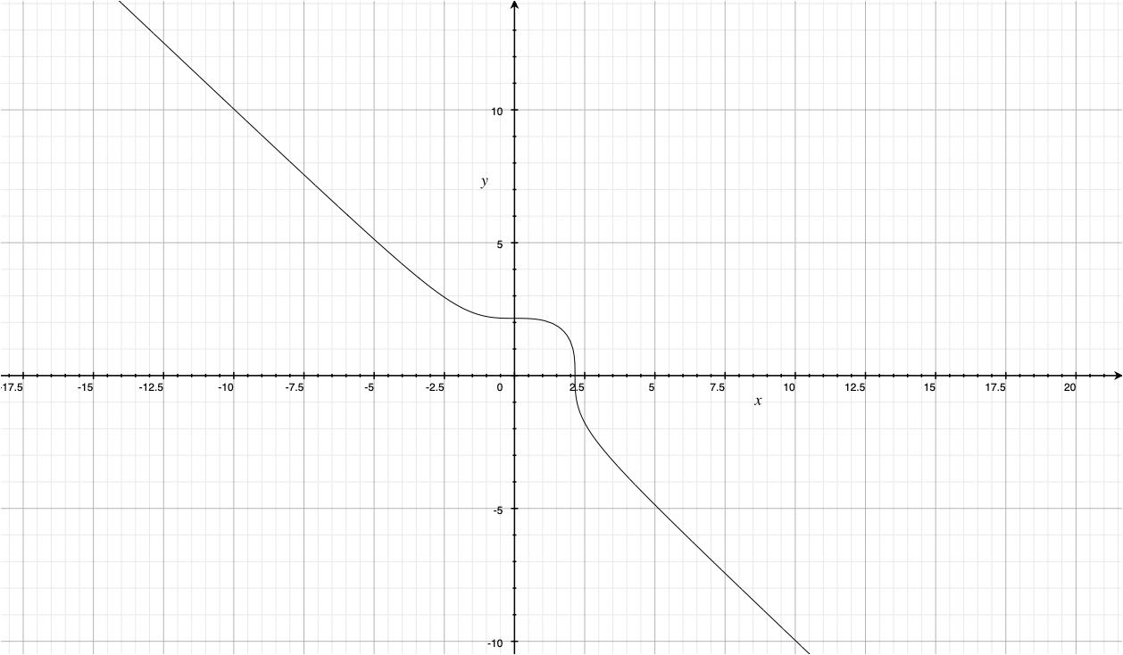

**z=x^3+y^-10**

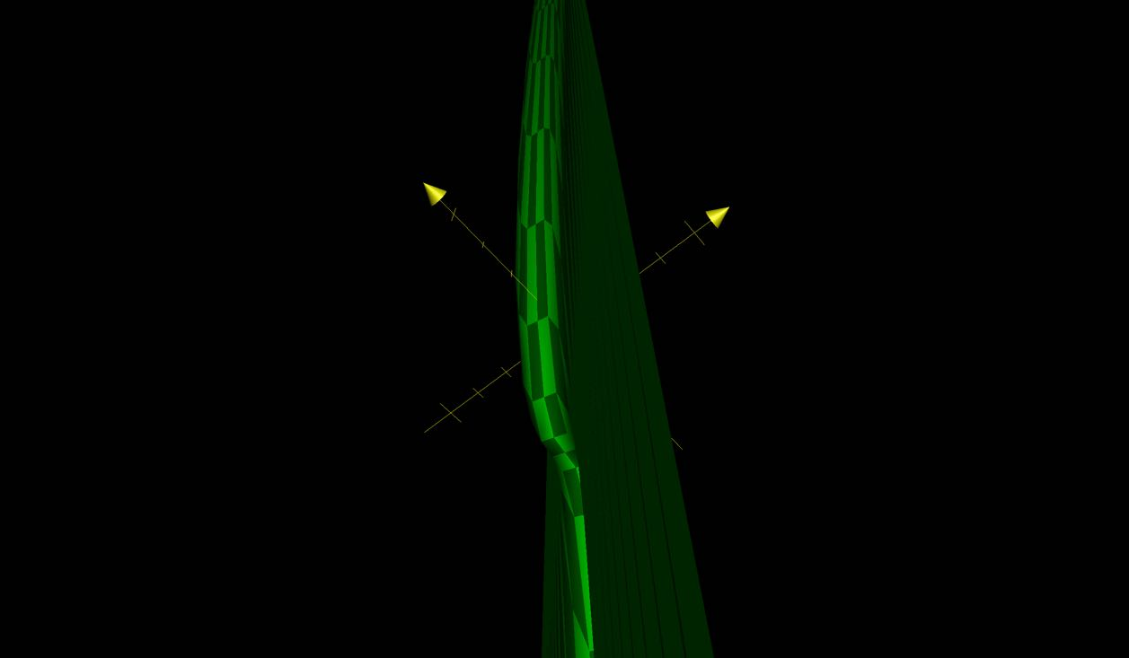

**Q2.x^3-y^3=100**

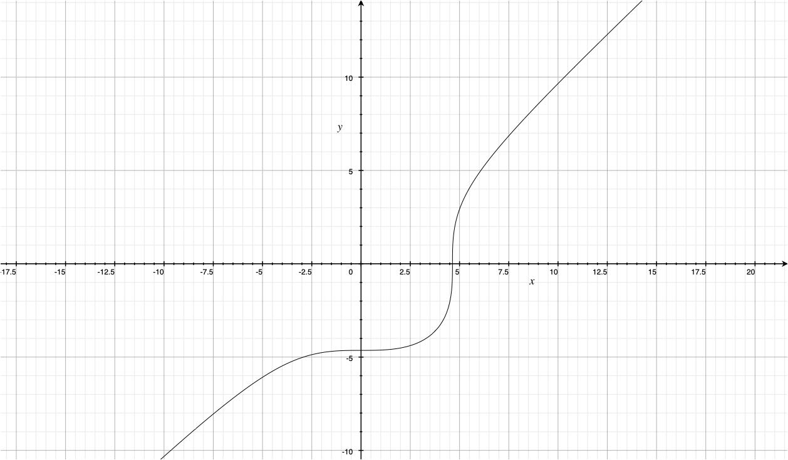

**z=x^-y^-100**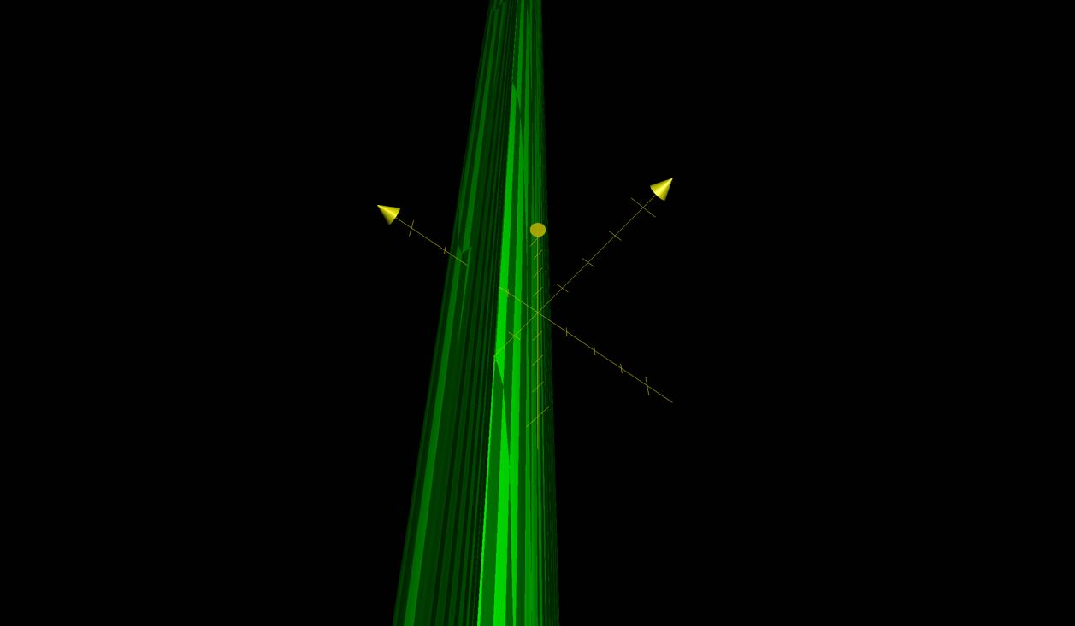

**Q3.x^2/25+y^/36=1**

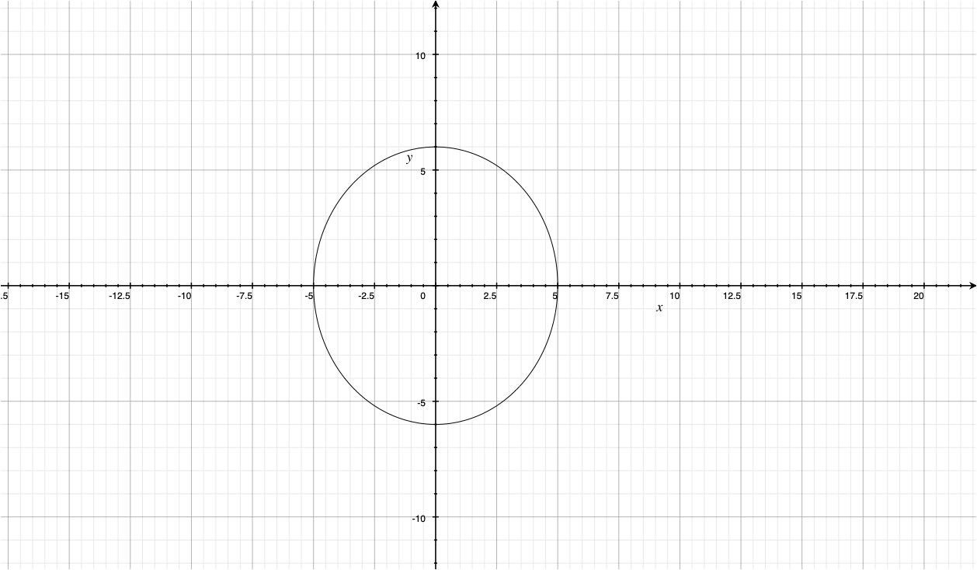

**z=x^2/25+y^/36-1**

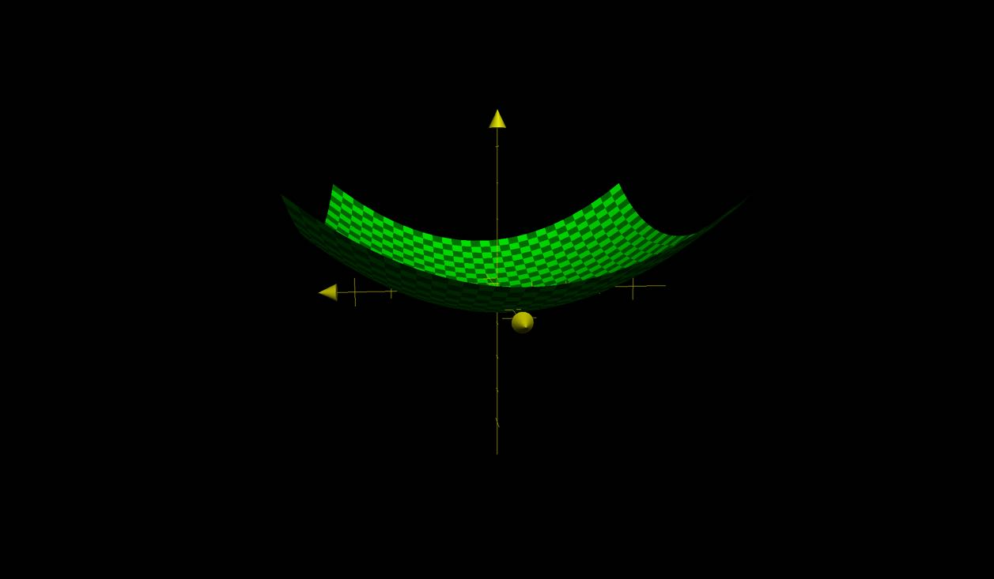

**Q4.y^2/16-x^2/9=1**

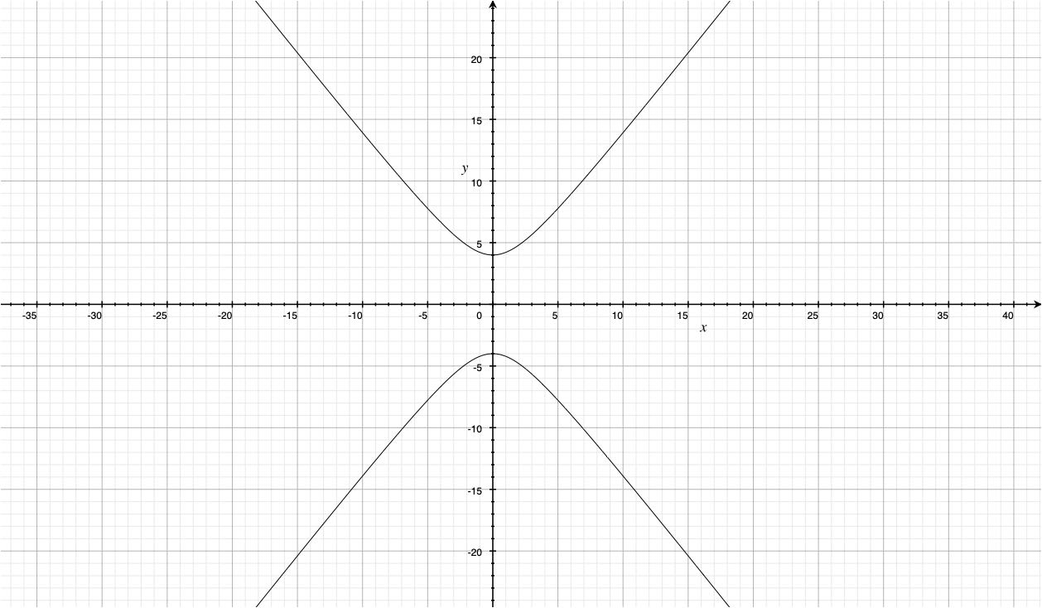

**z=y^2/16-x^2/9=1**

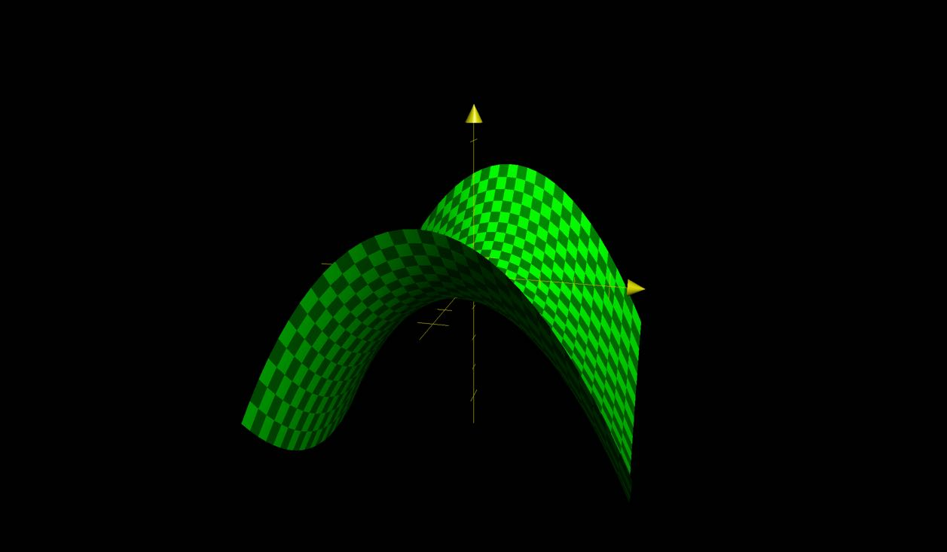

**Q5.y=**

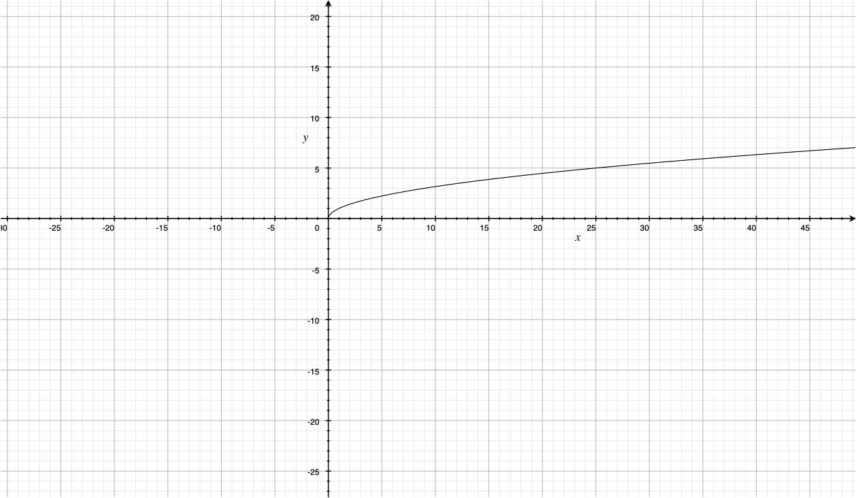

**z=-y**

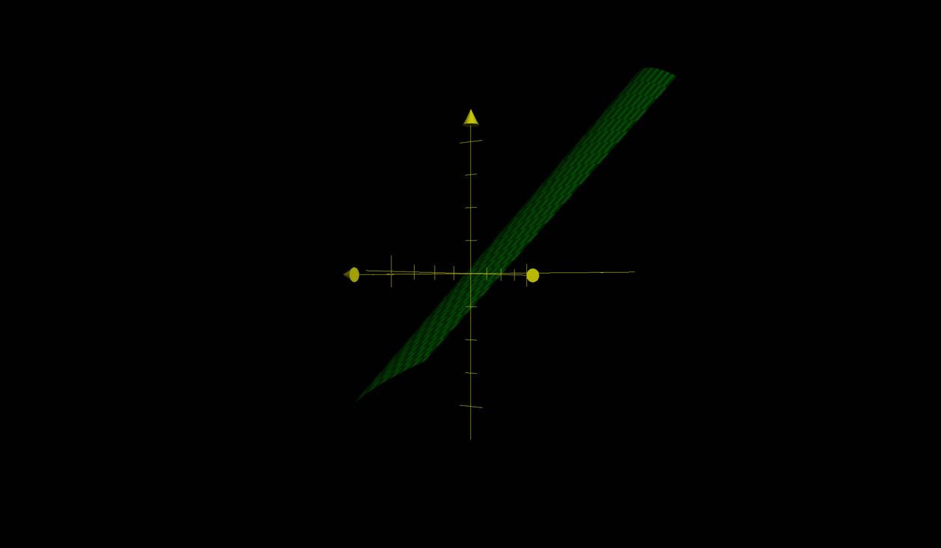

**Q6.y=cos(x+15)**

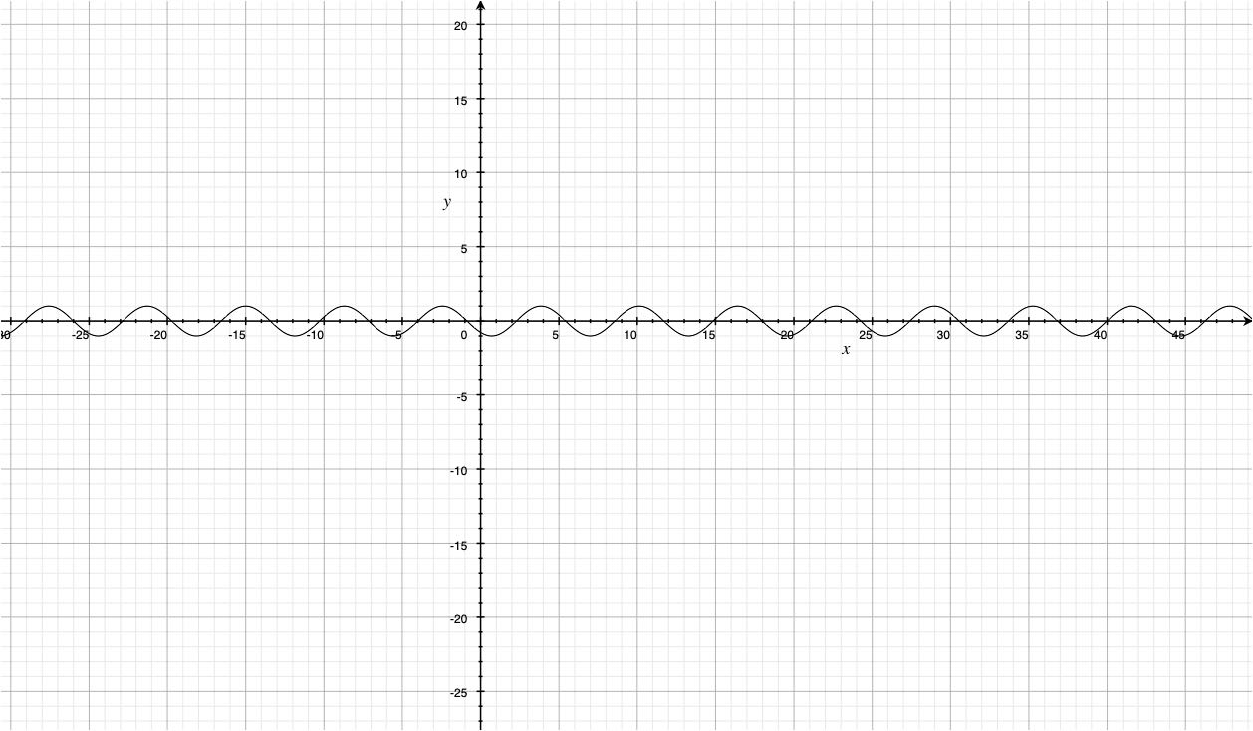

**z=cos(x+15)-y**

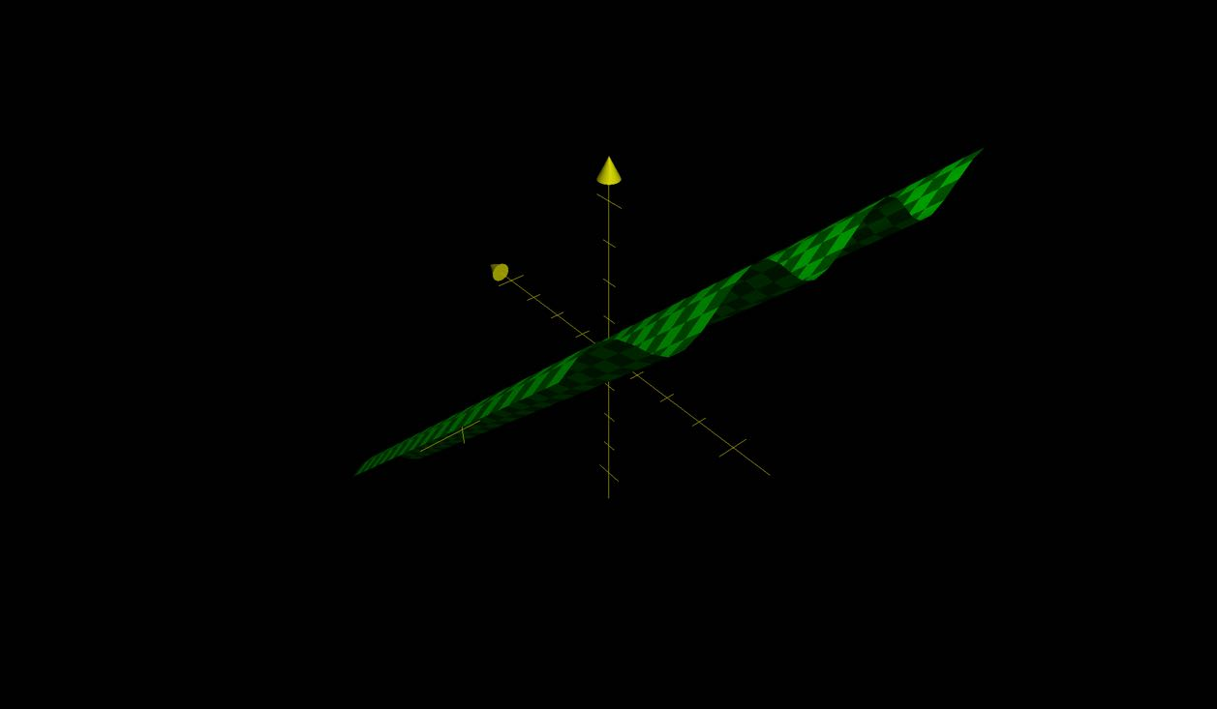

**Q7.y=cosx+15**

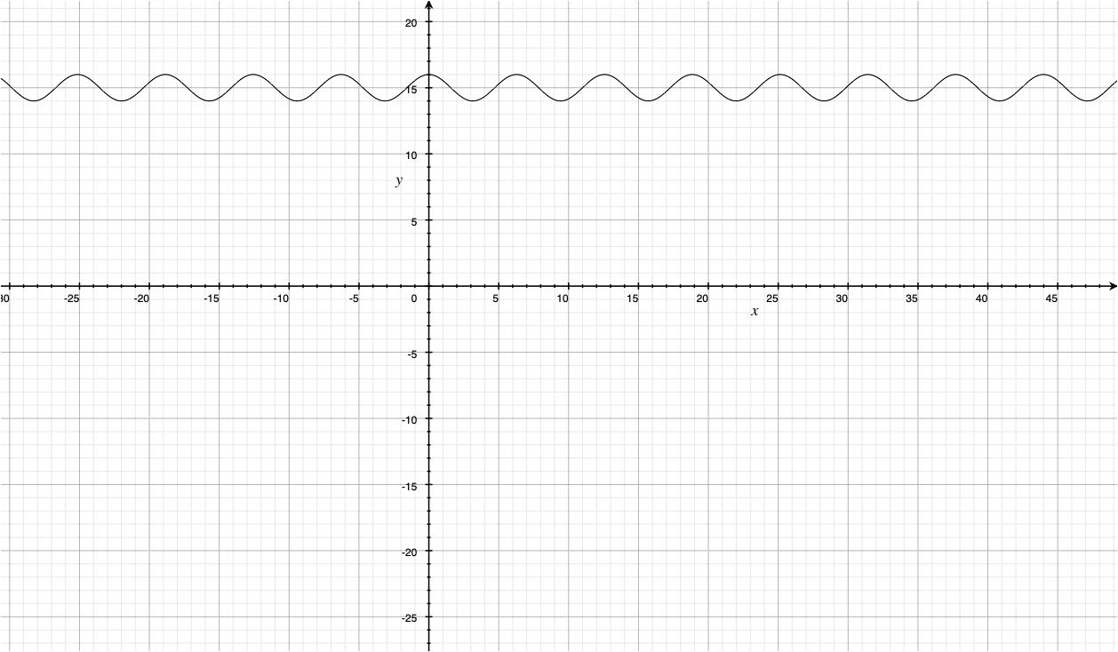

**z=cosx+15-y**

